21 Editors - Text Editor
Text Editor 3
Header - File Menu 3
New Text 4
Open Text 4
Reload 4
Save 4
Save As 4
Run Script 4
Templates 4
Redraw Timer 4
Debug Menu 4
Reload Scripts 5
Header - View Menu 5
Properties 5
Top of File 5
Bottom of File 5
Area 5
Horizontal Split 5
Vertical Split 5
Duplicate Area into new Window 5
Toggle Maximize Area 5
Toggle Fullscreen Area 5
Header - Edit Menu 6
Cut 6
Copy 6
Paste 6
Duplicate Line 6
Move Line up 6
Move Line down 6
Select Text 6
Delete 6
Select all 7
Select Line 7
Go to Line 7
Find 7
Find & Set Selection 7
Text Auto Complete 7
Text to 3D Object 7
One Object 7
One Object Per Line 7
Header - Format Menu 7
Indent 7
Unindent 8
Comment 8
Uncomment 8
Toggle comments 8
Whitespaces to Spaces 8
Whitespaces to Tabs 8
Header - Tools 8
Header Tools without a text file loaded 8
Text File Browser Drop down box 8
New 8
Open 8
Show Line Numbers, Wrap and Syntax Highlight 8
Header Tools with a text file loaded 8
Text File Browser Drop down box 9
Text File Browser Edit Box 9
Run Script 9
Register 9
Info String 9
Show Line Numbers, Wrap and Syntax Highlight 9
Tool Shelf 9
Properties Panel 9
Highlight 9
Live Edit 10
Font Size 10
Tab width 10
Show Margin 10
Margin Column 10
Find & Replace Panel 10
Find Edit Box 10
Find set selected 10
Find Next 10
Replace Edit Box 11
Replace set selected 11
Replace 11
Replace all 11
Match case 11
Wrap 11
All 11
Footer 11
Info String 11
Context menu 12
Cut 12
Copy 12
Paste 12
Move Line up 12
Move Line down 12
Indent 12
Unindent 12
Toggle comments 12
Text Auto Complete 12

Text Editor

The Text Editor is mainly used to write scripts. And so the functionality orients towards this useage. But you can also use it to write any text. To store some notes for the scene for example. See Tip below.
When you don't have a file loaded then the header content is rather small.
Once you create a new file, or load a file, you will see the toolbar change, and reveal further functionality.
Some text related functionality can also be found in the tool shelf at the right.
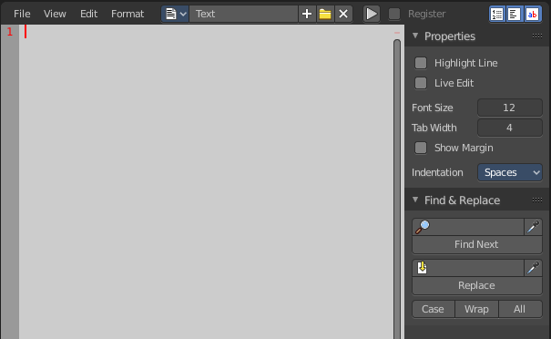

Tip
A Text window can be used to write in a README text explaining the contents of your blend file. Be sure to keep it visible when saving! And be sure to tell the receiver to activate Load UI to display the text file then. Bforartists has Load UI deactivated by default.

Header - File Menu
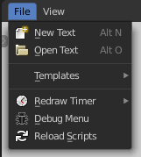
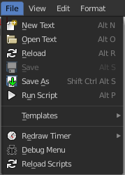
The File menu contains the load and save functionality. But also some Python and OSL templates. And some general debug functionality.

When no text is loaded then the menu is reduced.

New Text
Creates a new text file.

Open Text
Open a text file.

Reload
It can happen that you work with an external script editor, like Visual Studio, and change your script there. The reload button reloads the current active text file from hard disk.
You will get a warning symbol in the header when the script in the text editor doesn't match with the external text anymore.

Save
Saves the text file. Overwrites the existing version immediately.

Save As
Save as opens a save as file dialog.

Run Script
This button is for python or OSL scripts. It executes the script.

Templates
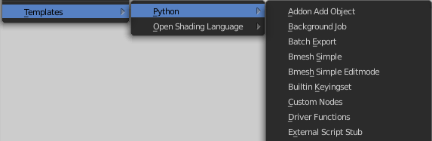
The Templates category contains some example scripts. There are two kind of templates. Python scripts and Open Shading Language scripts. The name of the files should tell you what the script is good for.

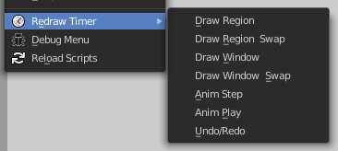
Redraw Timer
This is a relict from early Blender days. A debugging timer for the UI where you can test the redraw time of different UI elements.

Debug Menu
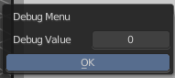
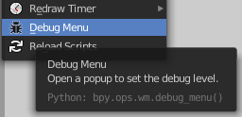
Another development tool. Set the debug level.

Reload Scripts
Reload Scripts reloads all active python scripts and addons. Including the Bforartists python UI files. This can be useful when you work at the UI or at an add-on. Then you don't have to close and reload Bforartists to see the changes. You can simply reload the scripts and keep Bforartists open.

Header - View Menu
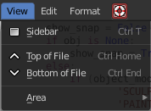
The View menu contains some view related functionality.

Properties
Opens or closes the Properties sidebar.

Top of File
Jumps to the top of the text file.

Bottom of File
Jumps to the bottom of the text file.

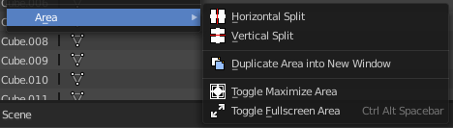
Area
Area is a menu with window related settings.

Horizontal Split
Splits the editor horizontally into two editors.

Vertical Split
Splits the editor vertically into two editors.

Duplicate Area into new Window
Creates a floating window out of the current editor

Toggle Maximize Area
Displays the editor maximized with menus.
To return to split view press hotkey Ctrl Up Arrow, or reuse the menu item in the View menu.

Toggle Fullscreen Area
Displays the editor maximized without menus.
To return from the full screen view press hotkey Alt F10, or use the little button that appears up right when you move the mouse in this corner.

Header - Edit Menu
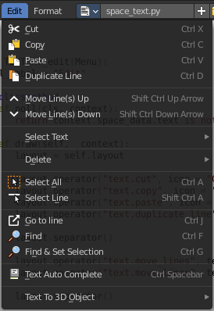
The Edit menu contains tools to modify the text.

Cut
Cuts the selected text.

Copy
Copies the selected text.

Paste
Pastes copied text at Text cursor position.

Duplicate Line
Duplicates the line where the Text cursor currently is.

Move Line up
Moves the line where the Text cursor is one line up.

Move Line down
Moves the line where the Text cursor is one line down.

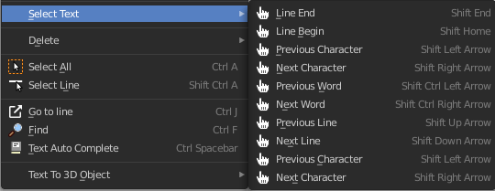
Select Text
Select text is a sub menu that contains selection functionality, starting from the current position of the Text cursor. The buttons should be self explaining. And usually you use the hotkeys for this functionality.

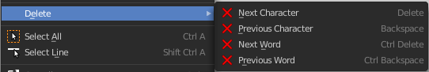
Delete
Delete is a sub menu with some special Delete methods, starting from the current position of the Text cursor. And usually you use the hotkeys for this functionality.

Select all
Selects all text.

Select Line
Selects the line where the Text cursor. currently is

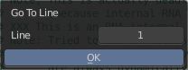
Go to Line
This tool opens a sub menu where you can type in the line number and jump to this line then.

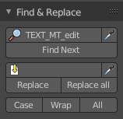
Find
Find opens the Tool Shelf, where you can find a Find & Replace panel. The Find & Replace panel is explained in the tool shelf chapter.

Find & Set Selection
Finds and selects the next text element that matches with the current selection. It's the same functionality than the Find Next button in the Find & Replace panel.

Text Auto Complete
Auto Complete tries to complete your text input.

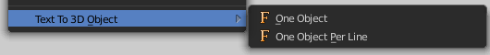
Text to 3D Object
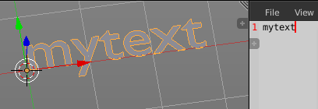
Text to 3D Object converts the text of the file to an editable 3D object in the 3D Viewport.

One Object
Converts the whole text into one object.

One Object Per Line
Converts every line of the text into a separate object.

Header - Format Menu

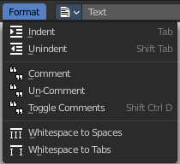
The format menu contains some formatting functionality.

Indent
Indents the text. Python requires proper indentation.

Unindent
Unindents the text.

Comment
Comments the text out. For Python usually with a # sign.

Uncomment
Uncomments commented text.

Toggle comments
Toggles the comments.

Whitespaces to Spaces
Converts Whitespaces in the text to Spaces.

Whitespaces to Tabs
Converts Whitespaces in the text to Tabs.

Header - Tools

The Header tools provides you with quick access functionality.

Header Tools without a text file loaded

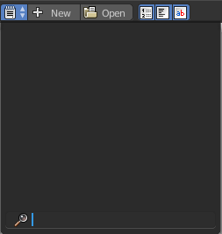
Text File Browser Drop down box
This list is empty when no file is loaded.

New
Creates a new text file.

Open
Opens a file browser where you can choose a file to load.

Show Line Numbers, Wrap and Syntax Highlight
See below.

Header Tools with a text file loaded

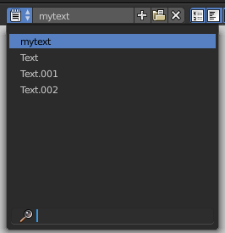
Text File Browser Drop down box
This list shows you the currently loaded text files.

Text File Browser Edit Box
The edit box allows you to rename the currently active text file.
The + Button behind allows you to create a new text file.
The Button with the folder at it calls a file browser where you can load files.
The X button at the end unlinks the text file, means it deletes it from the Text file browser list.

Run Script
This button is for python or OSL scripts. It executes the script.

Register
This checkbox is for Python or OSL Scripts. When checked the classes of the script gets registered in Bforartists.

Info String
Shows infos about the current text file. When it's an internal created file then it displays the String File: Internal. When it's an external loaded file, then the string displays the path to the location of the file.

Show Line Numbers, Wrap and Syntax Highlight
Show Line numbers displays a row of numbers at the left side of the text file.
Wrap words wraps the text to fit into the current editor size.
Syntax highlighting colors text parts fitting to the language.

Tool Shelf

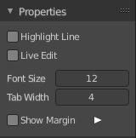
The Tool Shelf is the place for some options and the text search panel.

Properties Panel

Highlight
Highlights the line where the text cursor is.

Live Edit
Updates the script while editing.

Font Size
The font size for the text editor

Tab width
Number of spaces to display tabs with. Default is four.

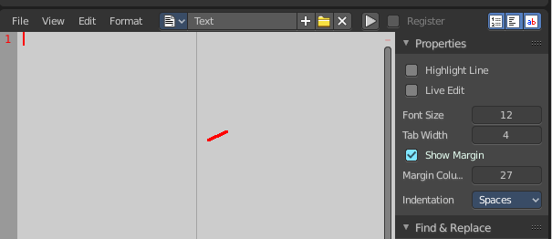
Show Margin
Shows a dotted line at the right. Note that we have currently a theming problem here with the default Bforartists theme. We have white text, means a white dotted line. And we have a white background. This means that the dotted line just shows with other themes where the header text color is black.

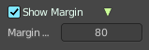
Margin Column
This edit box becomes visible when Show Margin is ticked.
Here you can adjust the width from the left at which the dotted margin line should show.

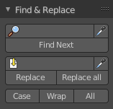
Find & Replace Panel
In the find panel you will find tools with text search and replace functionality.

Find Edit Box
Here you can type in the string that you want to search.

Find set selected
Copies the currently selected text into the Find edit box, searches for a matching string in the text, and selects this match then.

Find Next
Searches for the next matching string in the text.

Replace Edit Box
Here you can type in the string that you want to replace in the text.

Replace set selected
Copies the currently selected text into the Find edit box, searches for a matching string in the text, and replaces this match with the string in the Replace edit box.

Replace
Searches for the next matching string in the text. And replaces it the string in the Replace edit box.

Replace all
Searches for matching strings in the text. And replaces them all by the string in the Replace edit box.
Note
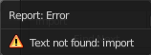
By default when the search does not find a matching string anymore in the text below the current selection, then you will get a warning that the search string is not present in the text file. It will not automatically start the search from the top again. You have to place the text cursor manually at the top of the text.

Or turn on the Wrap checkbox below.

Match case
When ticked then the search is Upper case sensitive.

Wrap
Starts the search from the top of the document when the search has reached the end of the document.

All
Search in all opened Text files, not just the currently active one.

Footer

Info String
This string shows infos about the current text file.
When it's an internal created file then it displays the String File: Internal.
When it's an external loaded file, then the string displays the full path to the location of the file.

Context menu

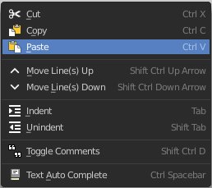
When you right click into the text editor then a popup menu opens up. It is to 100% made of double menu entries.

Cut
Cuts the selected text.

Copy
Copies the selected text.

Paste
Pastes copied text at Text cursor. position.

Move Line up
Moves the line where the Text cursor. is one line up.

Move Line down
Moves the line where the Text cursor. is one line down.

Indent
Indents the text. Python requires proper indentation.

Unindent
Unindents the text.

Toggle comments
Toggles the comments.

Text Auto Complete
Auto Complete tries to complete your text input.

